Tim Rush Bio
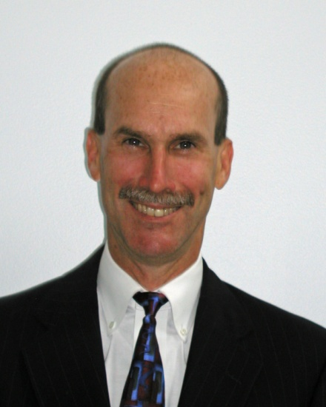
Tim Rush has over 35 years experience in the commercial space industry leading multinational programs and structuring / negotiating complex agreements. He provided technical leadership during the industry’s early development building, launching and operating commercial satellites. As the industry matured and commercialized, Tim became a financial advisor and space insurance broker providing risk management guidance and orchestrating placement of property and liability insurance programs for businesses that launch and operate assets in space. Tim also lead satellite risk due diligence efforts for several sector mergers and acquisitions and served as insurance advisor to secured lenders and export credit agencies.
Tim has a Bachelor of Mechanical Engineering degree from the University of Delaware and a Master of Business Administration degree from the University of Maryland. He often speaks at industry events including annual satellite conferences in Washington DC, Silicon Valley, and the World Space Risk Forum.

